LAB 5 REPORT
Objective: The main objective of lab5 is to implement NIOS II and print helloworld program into NIOS II processor.
Key Note: I use intel Quartus prime 18.1 lite for this lab 5. Although I tried to solve this with 20.1, but intel introduced WSL Linux subsystem after version 18. WSL is highly dependency and little buggy and not a stable one till date which I feel. Although I designed NIOS with 20.1, but when I build program in NIOS II then it causes several issues.
Part 1: Part1 is to implement NIOS II. Here I will provide the screenshot and the verbal text in a hierarchy manner.
- First, I create a project Wizard what we did in our previous labs.
- After creating the project, Open Platform design.
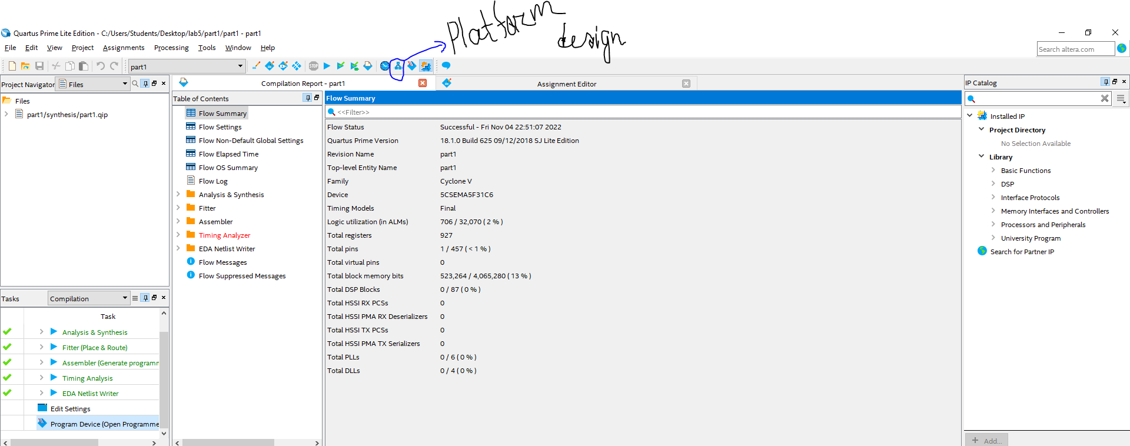

- The platform design will be look like below one and all the component will be found in the marking area.
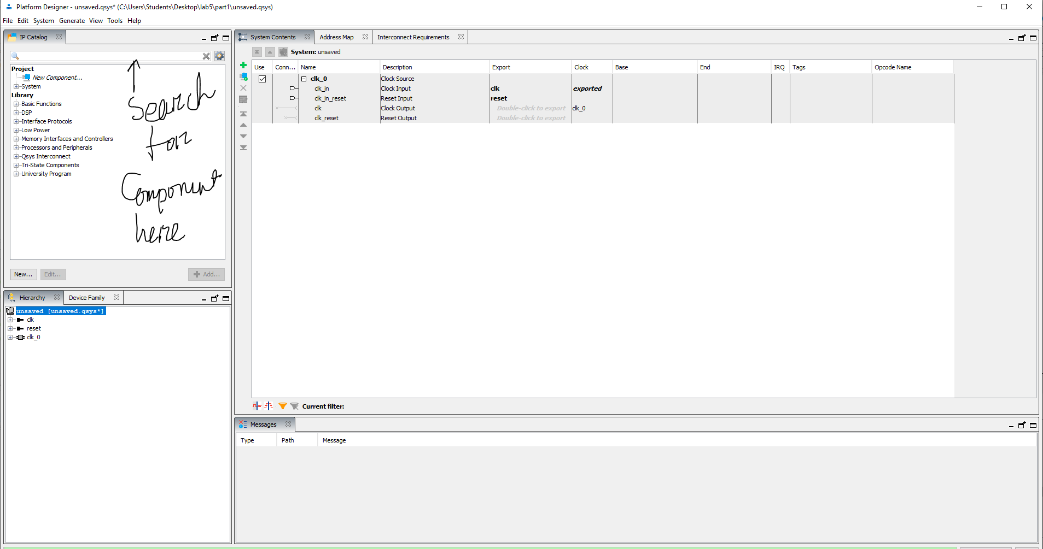
- After that I add NIOS II processor (choose NIOS II/e because it is worked with free version), on chip Memory RAM/ROM, and JTAG UART Intel FPGA IP from the component. In on chip memory, I change the memory to 64000 bytes as with 4096 bytes I got error of elf file not generated. The screenshot of the adding those components is below:
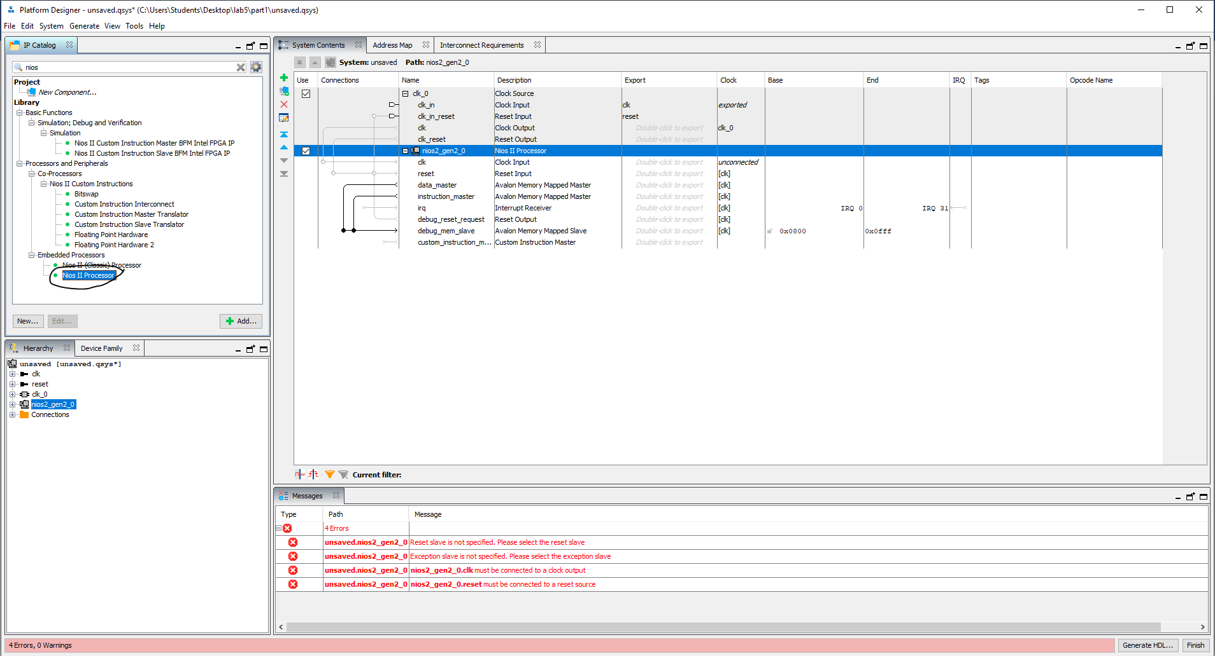
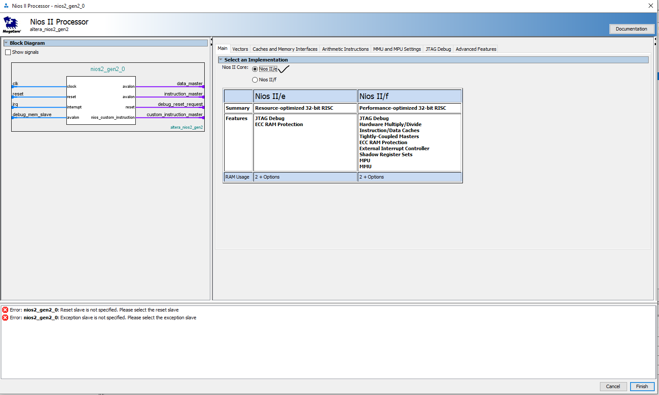
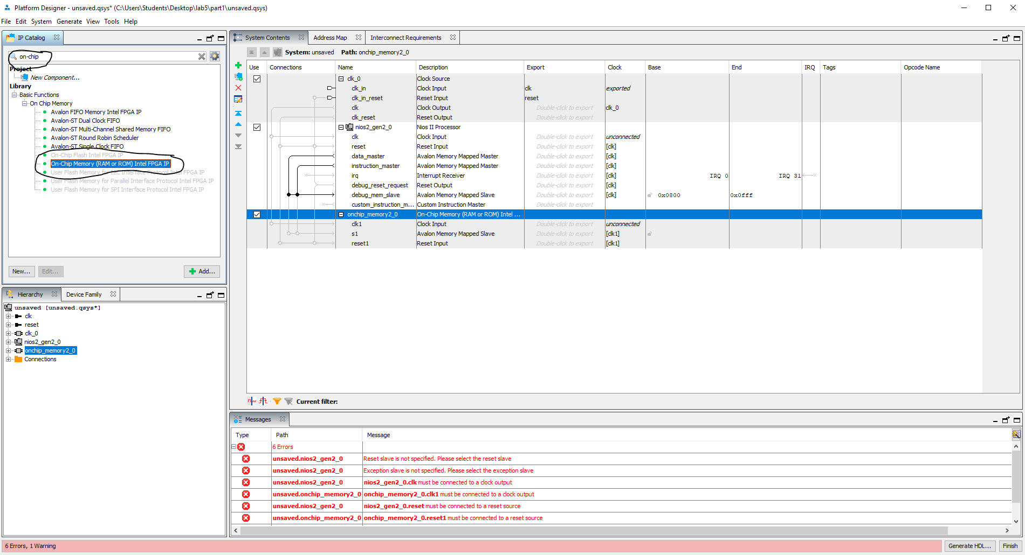
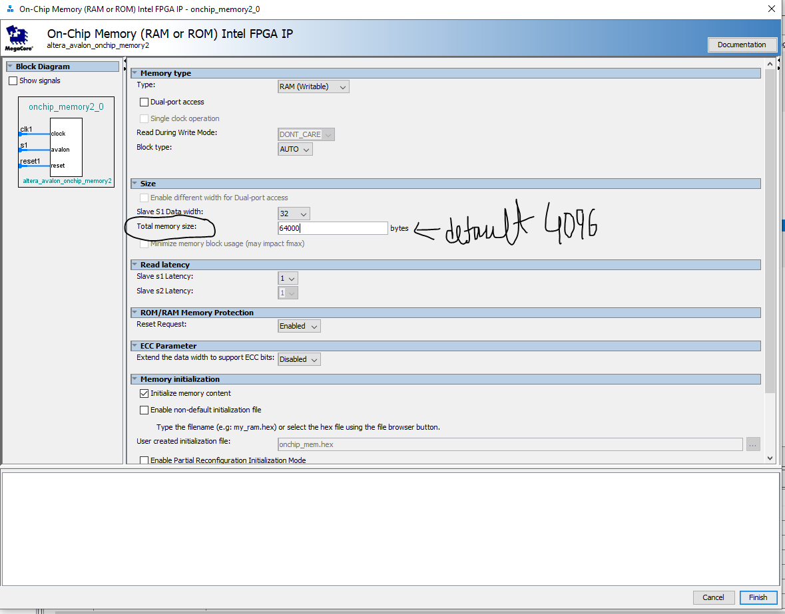
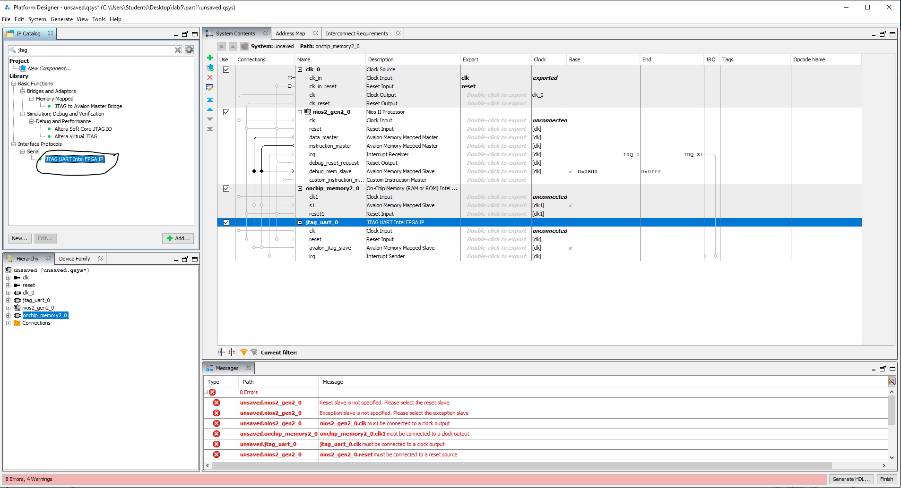
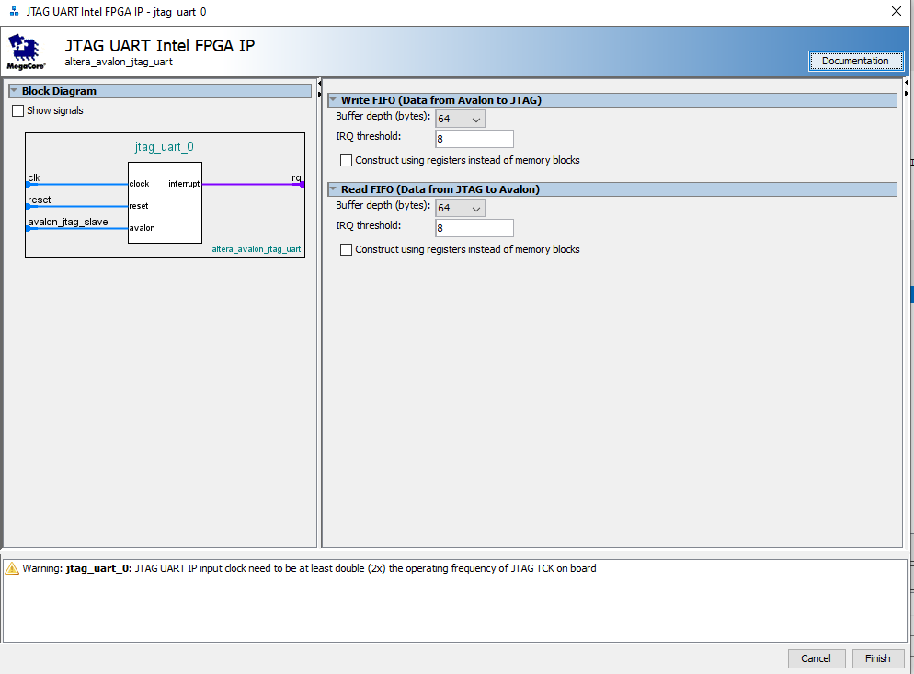

- After adding all the components, I need to wire those components. I need to wire all the clocks, reset button along with instruction master. The complete wire is in below:
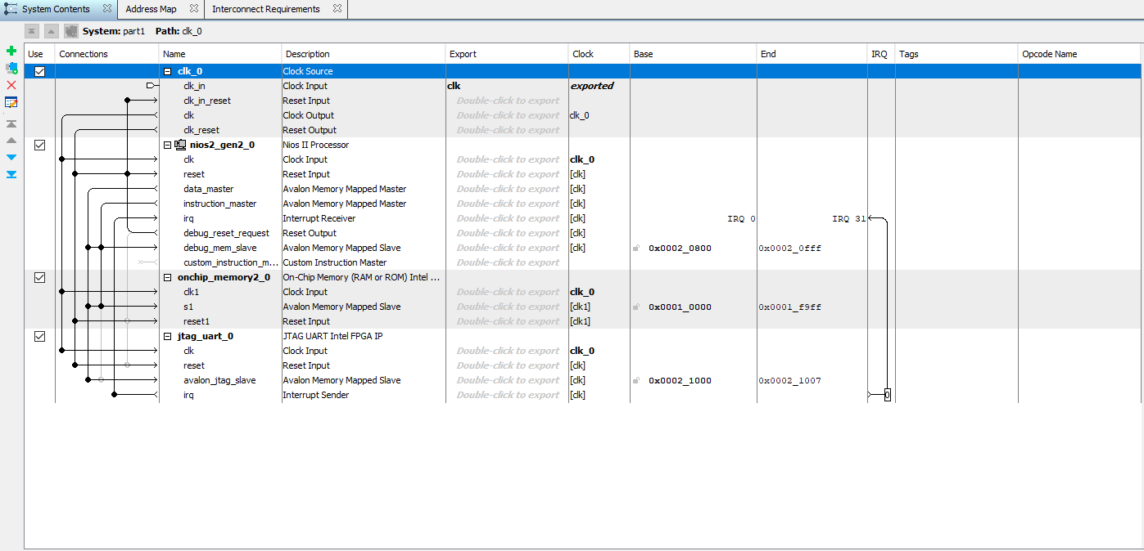
- Then I select NIOS II processor and set the vector memory to on chip RAM.
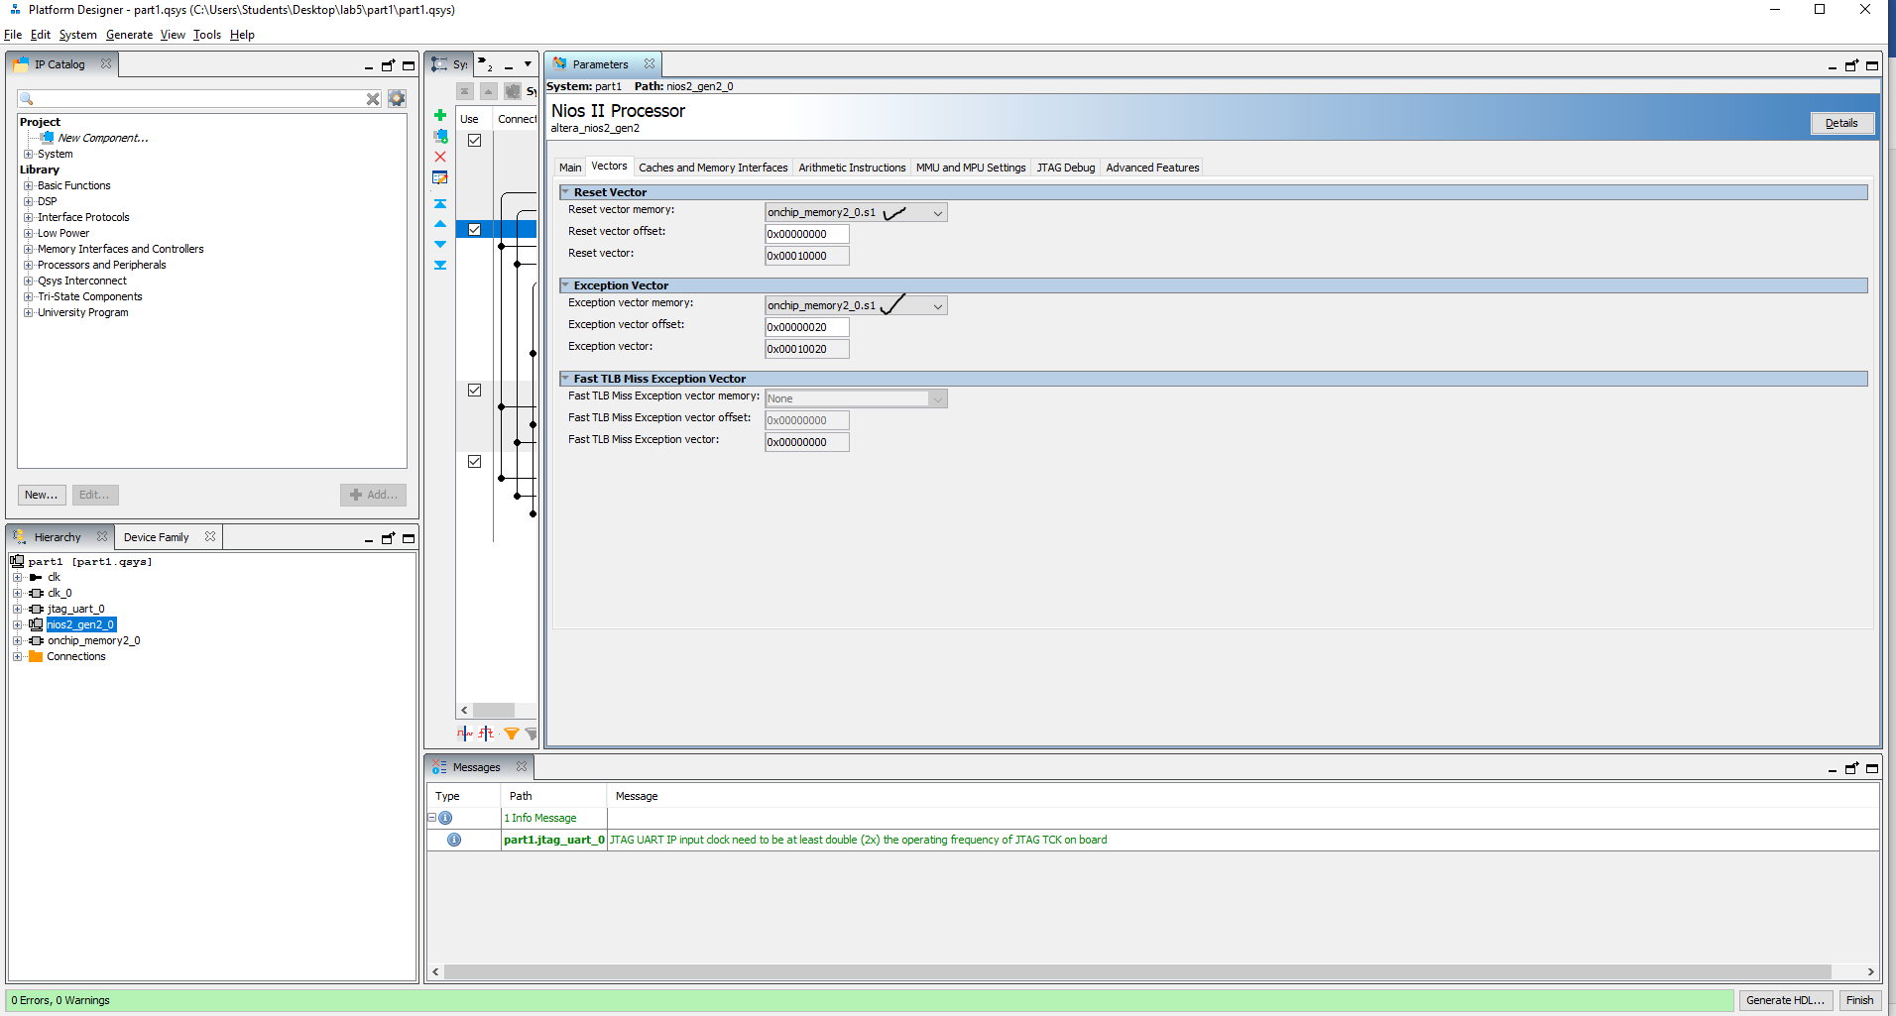
- Then click system-> Assign base addresses.
- After that click Generate which will generate the VHDL and synthesis files.
- Now Close the platform designer and get back to Quartus window.
- In the Quartus we need to first add the .qip file clicking the side menu.
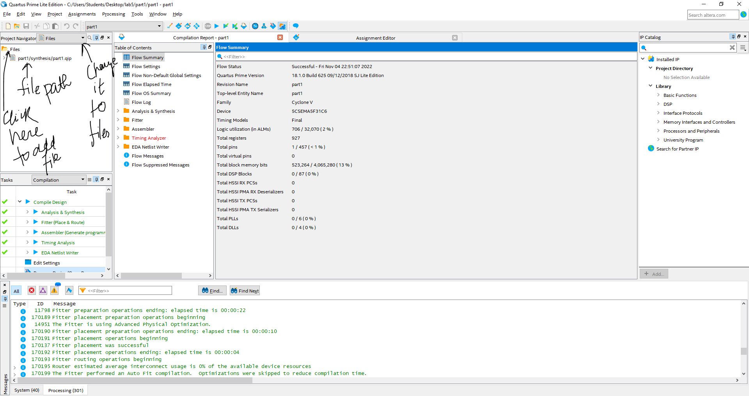
- Compile the design and after successfully compile the design just following the previous method with programmer to implement in DE1-soc board.
Part 2: In the part 2, I implement hello world in the implemented NIOS II.
- I open the eclipse from the menu in Quartus tools-> NIOS II Software build tools for Eclipse . It will open the eclipse mars.
- Add new project in eclipse clicking NIOS II application and BSP from template
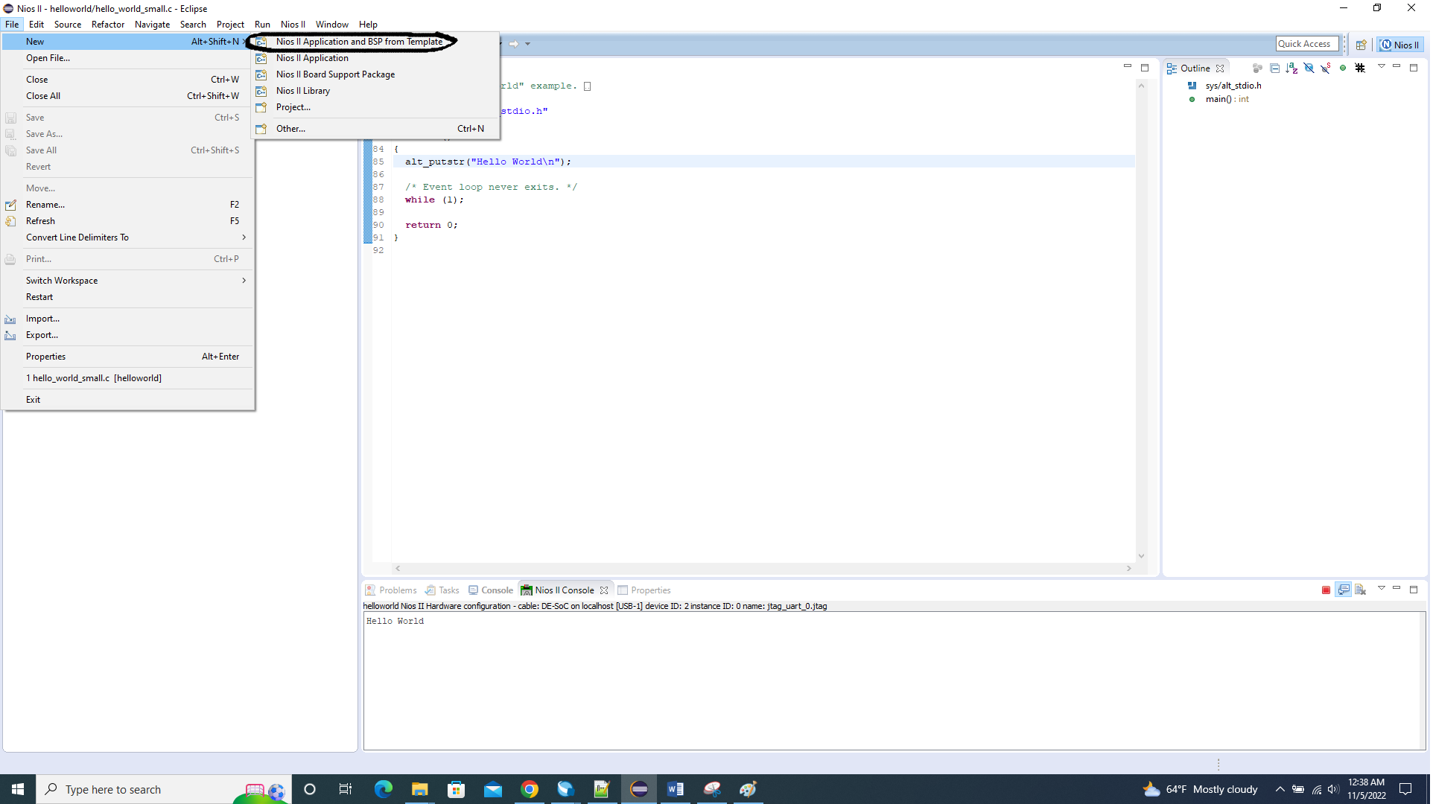
- Add the SOPC files which will be in the Quartus folder with an extension .sopcinfo. After that I add the project name and project application folder. choose Hello world small template .
- Click finish after adding all the fields will create two files. one is a bsp files which contains all the hardware drives and another is software file which contains program files.
- Then build the project and run as -> NIOS II hardware. It will show hello world in console.
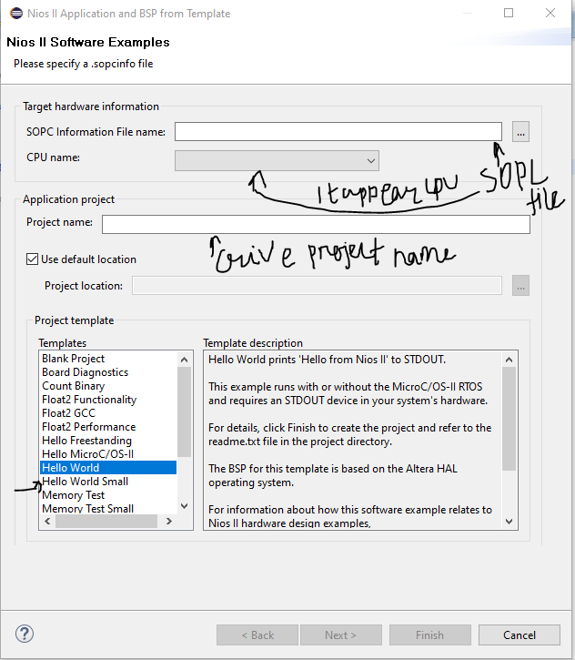
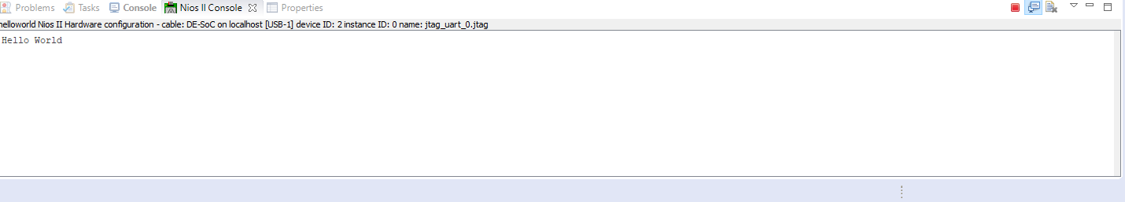

Note: All the files are inside the part1 folder. Software files are in part1/software.

